**Create Node-RED Service**

**Aim**: To create a web application create a Node-RED service.

**Steps followed:**

* Navigated to the App creation page

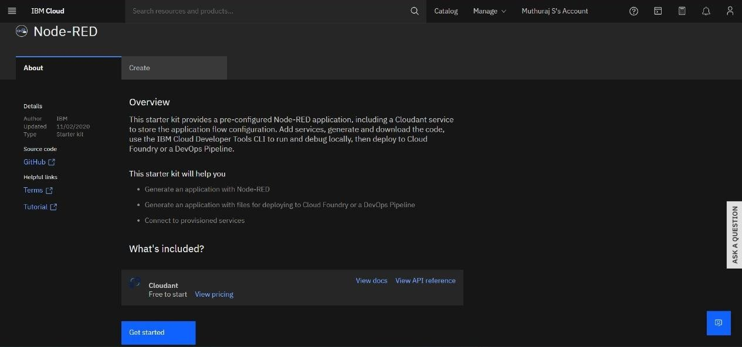

* Entered project details and clicked on create

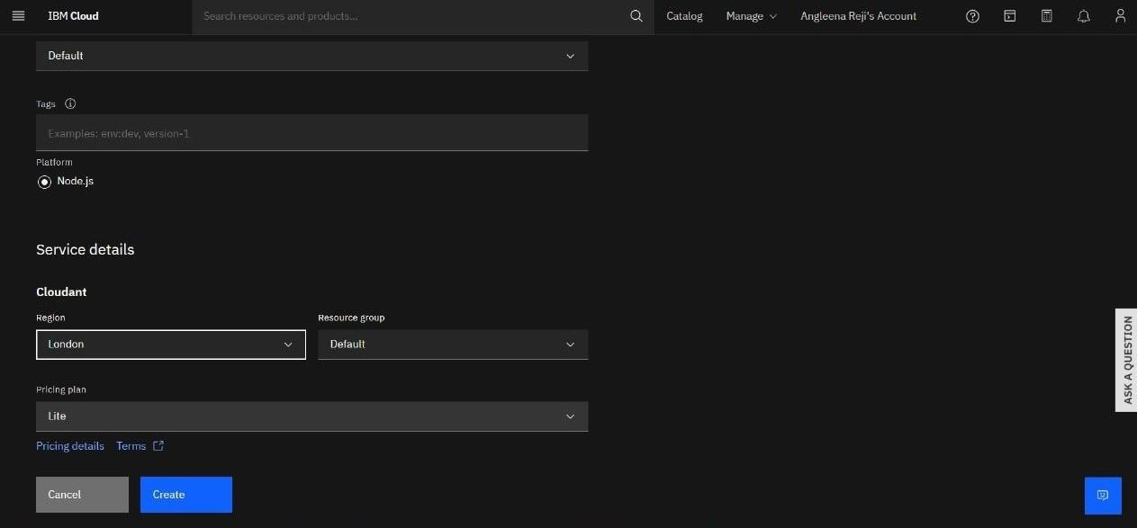

* Clicking on the “Deploy your App” Button

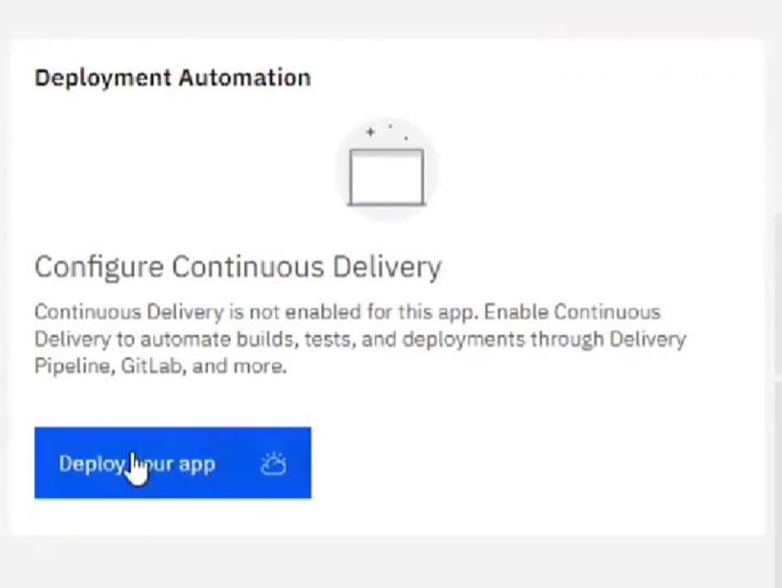

* Setting up the environment and deploying the app

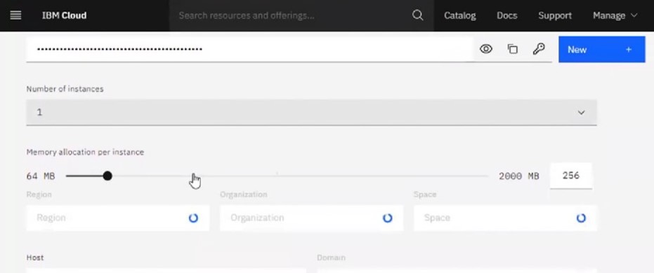

* Successfully deployed the app

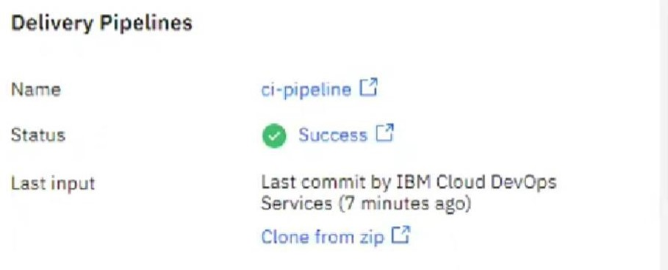

* Dragged and dropped components into the editor

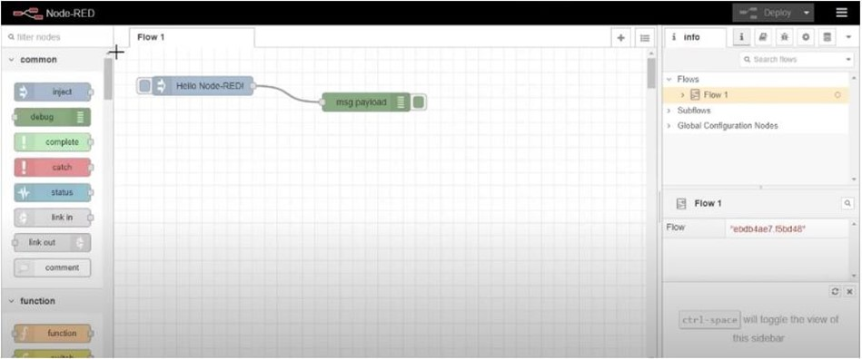

* Editing some values of the properties

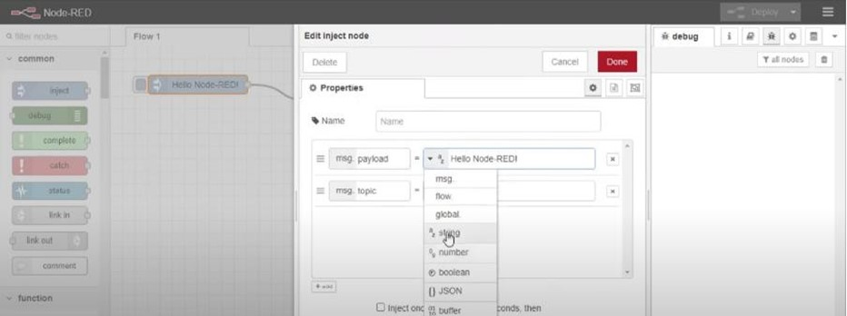

* Successfully deployed the app

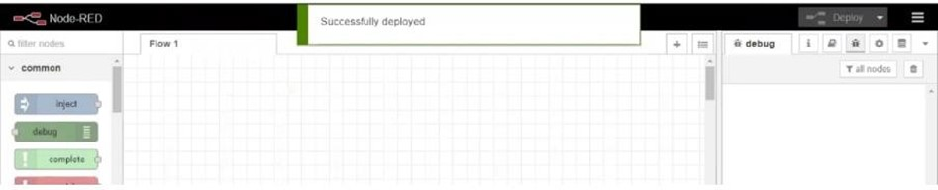

**Result:** Successfully created a NodeRED service on IBM Cloud